CIS2520_Intro_to_SQL - Section 8 Creating Tables & Section 9 Constraints
Student Name: Alan Himes
Section 8 Lesson 1
- Write the syntax to create the grad_candidates table.
Use the diagram below for table details.
Make the Student Id a Primary Key
Create NOT NuLL constraints for First Name, Last Name

Use Varchar2(25) for last and first name.
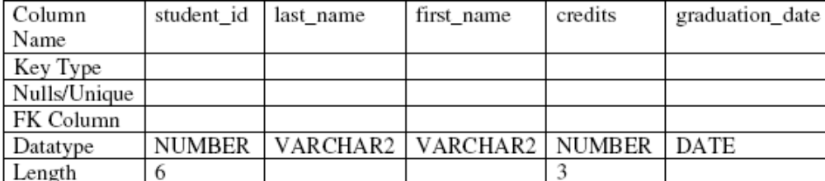
create table grad_candidates
(student_id number(6,0),
last_name varchar2(25) constraint GRAD_CAND_LN_NN not null,
first_name varchar2(25) constraint GRAD_CAND_FN_NN not null,
credits number(3,0),
graduation_date date,
constraint GRAD_CAND_ID_PK primary key(student_id));

- Add a column to the Grad_candidates table(Use an ALTER table command)
Major_ID NUMBER(3)

alter table grad_candidates add (major_id number(3));

SECTION 10 CONSTRAINTS- Section 10 Homework
- Create this Global_Locations table for Global Foods
Name your constraints properly for example: Global_loc_id_PK
Make the ID the Primary Key ,
Make EMAIL to have a UNIQUE constraint
Make NOT NULL Constraints for the columns that don’t have an X in them.
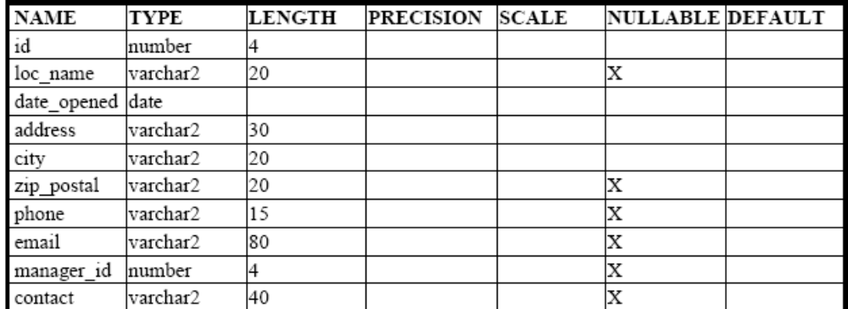

create table global_locations
(id number(4,0),
loc_name varchar2(20) constraint g_loc_name_nn not null,
date_opened date,
address varchar2(30),
city varchar2(20),
zip_postal varchar2(20) constraint g_loc_zip_nn not null,
phone varchar2(15) constraint g_loc_phone_nn not null,
email varchar2(80) constraint g_loc_email_nn not null,
manager_id number(4) constraint g_loc_mgr_id_nn not null,
contact varchar2(40),
constraint g_loc_id_pk primary key(id),
constraint g_loc_email_un unique(email));

- Using the column information for the animals table below, name constraints where applicable at the table level, otherwise name them at the column level. Define the primary key (animal_id).
The license_tag_number must be unique.
Create NOT NULL constraints on all columns
Name your constraints properly example: animal_adopt_id_PK
Name: Animal_adopt
animal_id NUMBER(6)
name VARCHAR2(25)
license_tag_no NUMBER(10)
admit_date DATE
adoption_id NUMBER(5),
vaccination_ID Number (4)

create table animal_adopt
(animal_id number(6,0) constraint a_adopt_animal_id_nn not null,
name varchar2(25) constraint a_adopt_name_nn not null,
license_tag_no number(10,0) constraint a_adopt_license_nn not null,
admit_date date constraint a_adopt_date_nn not null,
adoption_id number(5,0) constraint a_adopt_adoption_id_nn not null,
vaccination_id number(4,0) constraint a_adopt_vacc_id_nn not null,
constraint a_adopt_animal_id_pk primary key(animal_id),
constraint a_adopt_license_un unique(license_tag_no));

4. Enter one row into the table. Execute a SELECT * statement to verify your input.
Refer to the graphic below for input.

insert into animal_adopt values (101, 'Spot', 35540, '10-OCT-04', 205, 4000);
5. Create the vaccination table below:
vaccination_ID NUMBER (4) PRIMARY KEY
vaccination_name VARCHAR2(20) NOT NULL
Vaccination_Exp_date DATE NOT NULL

create table vaccination (
vaccination_id number(4),
vaccination_name varchar(20) constraint vacc_name_nn not null,
vaccination_exp_date date constraint vacc_date_nn not null,
constraint vacc_id_pk primary key(vaccination_id));

Add this record to the Vaccination table:
vaccination_ID vaccination_name Vaccination_Exp_date
4000 parvo 01-NOV-10

insert into vaccination values(4000, 'parvo', '01-NOV-10');

6. Use an ALTER table to add a FOREIGN key to the ANIMAL ADOPT table
Relating back to the Vaccination ID in the Vaccination table.

alter table animal_adopt add constraint a_adopt_vacc_id_fk foreign key(vaccination_id) references vaccination(vaccination_id);

7. Now add this record to the ANIMAL _ADOPT TABLE
Animal ID Name LicenseTag admit_date adoption_Id vaccination_ID
102 Princess 35545 15-NOV-10 209 4001

7a. What happens?? Di d the insert go through or an error explain?

Error starting at line 1 in command:
insert into animal_adopt values (102, 'Princess', 35545, '15-NOV-10', 209, 4001)
Error report:
SQL Error: ORA-02291: integrity constraint (CNMBJ_2520_S09.A_ADOPT_VACC_ID_FK) violated - parent key not found
02291. 00000 - "integrity constraint (%s.%s) violated - parent key not found"
*Cause: A foreign key value has no matching primary key value.
*Action: Delete the foreign key or add a matching primary key.

7b. What would need to be done, to be able to insert this child record.

A record needs to be created on the parent table, vaccination, with a value of 4001 for vaccination_id.

Answer: Add this record to the Parent table (Vaccination):

4001 WildDog Syndrome 20-JAN-12 (don’t forget to commit it)

Now add the child record for Princess, (don’t forget to commit it).
Display the records in the Vaccination table. (select)
Display the records in the Adopt Animal table. (select)

insert into vaccination values (4001, 'Princess', '20-JAN-12');
insert into animal_adopt values (102, 'Princess', 35545, '15-NOV-10', 209, 4001);
commit;
select * from vaccination;
select * from animal_adopt;

